
CeDRIC GROLET


Chapter 1

1. Introduction
This topic is about food and dinning, the chef Cedric Grolet was chosen for this topic, A website created for his restaurants. There is a home page, store page; where there are his stores in different locations and a link to his real websites, a menu page as there is a book table page so customers can choose from the menu before ordering online and they can book a table in the restaurants finally about us page that talks about the chief and his restaurants as well as his work.

2. Purpose of the website
The website was designed for the customers of the chef Cédric Grolet so that they know more about his work and for it to be easy for them to choose from the menu and order online or book a table in the restaurant.

3. Target Audience
The audience is the fans of Cédric work and the ones who would like to try his pastries.

4. Wireframe

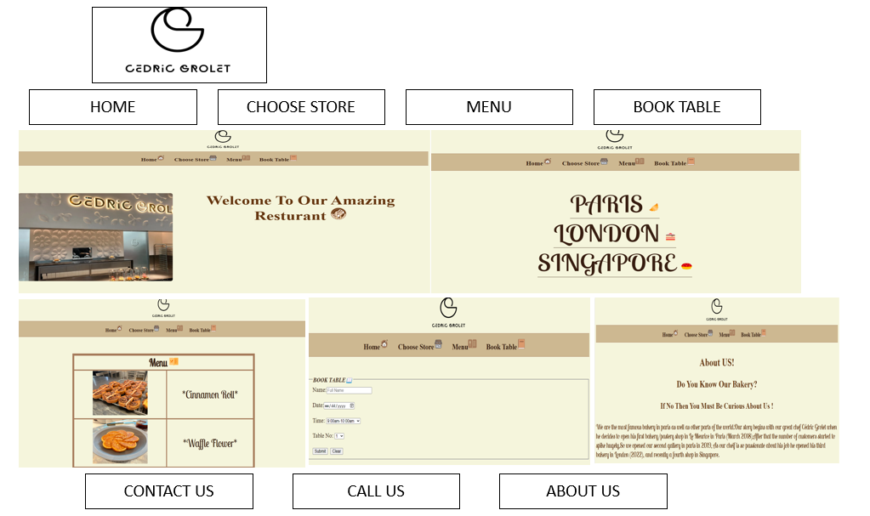

5. Sitemap
